Hope of Israel Ministries (Ecclesia of YEHOVAH):
The Count to Shavuot and YEHOVAH God's Weekly Cycle
Some have thought that keeping YEHOVAH God's Sabbath day according to the dictates of a lunar-based calendar completely disrupts the count from Passover to Pentecost. Is this true? Or, is this just another attempt to disparage YEHOVAH God's calendar and continue with the pagan Gregorian system we keep today? The very simplicity of YEHOVAH's calendar becomes apparent when we understand the ramifications of the CORRECT translation of Leviticus 23:15-16 -- and how to count to the SUMMER festival of Shavuot.
by John Keyser
The Old Testament Feast of Weeks or Shavuot is more commonly known as "Pentecost" -- a Greek word from the New Testament which means "fiftieth." This term "fiftieth," or Pentecost, refers to the counting of days from a specific point in time to the Feast of Weeks or Pentecost. This counting of days is called, by the Jews, the omer count, and links the day of Pentecost to the Passover season. In fact, Pentecost is considered a continuum of the Passover season.
Unclear Translations
To find where Pentecost appears on the calendar, the English translators of the Old Testament outline a method of counting which is, to say the least, a little unclear. For example, it says in Leviticus 23:15 to count from the "morrow after the sabbath," speaking of a Sabbath within the Feast of Unleavened Bread (Nisan 15 to Nisan 22). However, it doesn't clearly indicate WHICH sabbath it's talking about. As a result of this uncertainty, there has been a controversy among scholars and religious groups as to which "day after the sabbath" to begin the omer count from. This controversy has raged for millennia! The various theories that have been promulgated include counting from the day after the first day of Unleavened Bread (Nisan 16), counting from the day after the last high Sabbath of that festival (both of which are lunar related), to counting from the respective Sundays following each of the above!
Nisan 16 Date
A careful study of all the options clearly shows that the tradition of counting the omer from the second day of Unleavened Bread (Nisan 16) is the correct one. Both Josephus and Philo support this, as do many others --
"Instructions for this festival are found at Leviticus 23:15-21; Numbers 28:26-31 and Deuteronomy 16:9-12. It was meant to be celebrated on the 50th day (Pentecost means "Fiftieth [Day]") from NISAN 16, the day that the barley sheaf was offered (Leviticus 23:15, 16). In the Jewish calendar it falls on SIVAN 6. It was after the barley harvest and the beginning of the harvest of wheat, which ripened later than the barley." -- Exodus 9:31, 32. (Insight On the Scriptures, p. 598. Article, "Pentecost.").
Further, we read in The Temple: Its Ministry and Services As They Were At the Time of Christ:
"Full seven weeks after the Paschal [Passover] day, counting from the presentation of the omer on the 16th of Nisan, or exactly on the fiftieth day, was the Feast of Weeks, or Pentecost, 'a holy convocation,' in which 'no servile work' was to be done, when 'all males' were to 'appear before Jehovah' in His sanctuary, and the appointed sacrifices and offerings to be brought." -- Alfred Edersheim, pp. 261-262.
The Dead Sea scrolls also give a clear indication of how to count the omer --
"...You shall count seven complete Sabbaths from the day of your bringing the sheaf of the wave-offering. You shall count until the morrow of the seventh Sabbath. You shall [then] count [fifty] days. You shall bring a new grain-offering.....it is the feast of Weeks and the feast of Firstfruits, an eternal memorial" (From the Temple Scroll -- 11QT -- XVIII-XXI. Translation borrowed from The Complete Dead Sea Scrolls In English, by Geza Vermes).
Besides these references, the Greek Septuagint version of the Old Testament renders Leviticus 23:11 as saying, "...and he shall lift up the sheaf before the Lord, to be accepted for you. On the morrow of the first day [first day of the Feast, first day of the week -- exclusive counting] the priest shall lift it up," speaking, of course, of the barley sheaf. Then, in verses 15 and 16, it says that this is the very same day the counting is to begin --
"And ye shall number to yourselves from the day after the sabbath [Nisan 15 -- both annual Feast day and weekly Sabbath day], from the day on which ye shall offer the sheaf of the heave-offering [Nisan 16], SEVEN FULL WEEKS: until the morrow after the last week ye shall number fifty days, and shall bring a new meat offering to the Lord."
Weeks Versus Sabbaths
The term "Feast of Weeks" is found in two places in the Old Testament: Exodus 34:22 and Deuteronomy 16:9-10. The latter verses read: "SEVEN WEEKS shalt thou number to thyself; when thou hast begun to put the sickle to the corn, thou shalt begin to number SEVEN WEEKS. And thou shalt keep the FEAST OF WEEKS to the Lord thy God, accordingly as thy hand has power in as many things as the Lord thy God shall give thee."
However, in Leviticus 23 (Ferrar Fenton Version), it says --
"You shall also count for yourselves from the DAY AFTER THE SABBATH that you bring the Wave-sheaf, seven Sabbaths. They must be complete. Then AFTER THE SEVENTH SABBATH, you shall count fifty days, when you shall present a new offering to the EVER-LIVING. You shall bring from your dwellings two wave cakes of two tenths of fine [WHEAT] flour. They shall be fermented, -- baked in an oven for the EVER-LIVING" (verses 15-17).
Now notice the following points in the above verses:
1/. Verse 15 plainly says that SEVEN SABBATHS are to be counted. Notice that the term "sabbaths" is equated in this passage with "weeks" in Deuteronomy 16.
2/. Notice it says to begin counting from the morrow AFTER the Sabbath. The fact that the Sabbath it is speaking of here pertains to a feast day tends to connect high days to the weekly Sabbath. This I showed to be true in my article Have We Been Keeping the Sabbath At the Wrong Time All These Years?
3/. Instead of the "fifty days" paralleling the seven Sabbaths -- as we see in most translations -- Fenton clearly states that the "fifty days" are to be counted AFTER the seven Sabbaths are complete.
4/. The wave cakes are to be baked with WHEAT flour.
Gross Errors
When you consult the original Hebrew of Leviticus 23:15-16, it soon becomes apparent that Ferrar Fenton's translation is the CORRECT one! The Hebrew not only shows the gross error of almost all of the English translations, but also a deliberate hiding of the ACTUAL instructions given by YEHOVAH God to determine the date of His Feast of Shavuot.
The keeping of this feast -- from the time of Moses up through the New Testament book of Acts -- also shows that the modern keeping of the Babylonian-Greco Talmudic "Pentecost" matches neither the SEASON nor the MANNER of keeping as commanded by YEHOVAH God. So what happened -- how did we arrive at the modern "fifty day" count only to Shavuot?
Evidently, When Sabbatarians began to determine how to observe “Pentecost” (as given in the English translation of the Bible), they naturally did so in light of their Saturday-Sabbath keeping and their rejection of the pagan “Easter” for the Wave Sheaf Offering – the day when the Messiah rose from the tomb.
While they rightly rejected the false Sunday and Easter bases for determining the correct day of Shavuot, it appears that they accepted the erroneous premise of the modern PENTECOST and its simplified “count-fifty” method. Rather than exhaustively searching the Scriptures to confirm its validity as the New Testament EQUIVALENT to the Old Testament Feast of Shavuot or Weeks, they plunged into gross error along with pagan “Christianity.”
Had they gone back and studied the original Hebrew of Leviticus 23:15-16 without any preconceived ideas about “Pentecost,” they may have seen through the mistranslation. Aside from their acceptance of the erroneous modern “Pentecost” in place of the Feast of Shavuot, there is another EQUALLY erroneous and troublesome problem: Because of their acceptance of what the Jews came to call the fixed SATURDAY SABBATH of the pagan Roman calendar – rather than the ACTUAL weekly Sabbath based on YEHOVAH’s lunisolar calendar – they cannot comprehend that the SECOND DAY of Unleavened Bread is ALWAYS “the morrow [Nisan 16] AFTER the Sabbath” (Nisan 15 – first day of Unleavened Bread).
This compounding of errors was further complicated when certain church leaders ruled, for a number of years, that the Sunday (“morrow”) after the Saturday “Sabbath” in our pagan Gregorian calendar of today, that fell within Unleavened Bread was, NOT INCLUDED in the fifty-day count. This placed Pentecost on a Monday for some time – until it was later moved to Sunday. Talk about the blind leading the blind!
One Little Hebrew Word
Instead of wallowing around in the mire of erroneous concepts and deliberate falsifications, let us examine the critical passage in Leviticus 23 and study the Feast of Shavuot in the Bible to determine the HOW and the WHEN of accurately keeping the second of the three seasonal feasts of YEHOVAH God.
It appears that most translators, motivated by Jewish tradition and preconceived ideas stemming from the Catholic Whitsunday, failed to translate ONE little Hebrew word! What is that word? It's the word "MIN."
The beginning of verse 16, in the Hebrew, is "AD-MIN-MOCHORATH." The word "MIN" is a preposition which, when combined with other words, means "FROM." The Hebrew word "AD" is a preposition, adverb or conjugation that has many uses for describing TIME, SPACE or DEGREE. Ignoring the word "MIN," the translators render "AD" as "EVEN UNTO" -- however there is a major problem with this! The phrase "EVEN UNTO" deals with SPACE, while all of the measurements in verse 16 -- "the morrow," "the seventh Sabbath," and "fifty days" all deal with TIME, not SPACE! Therefore, the English translation for "AD" as "EVEN UNTO" is in error and CANNOT be correct since it deals with "SPACE" and not "TIME."
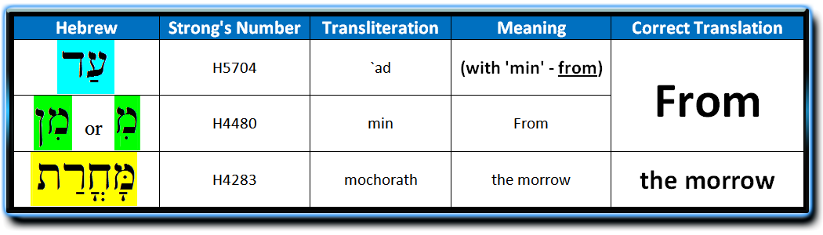
It would not be going out on a limb to state that this GROSS misapplication of "even unto" here has been very successful -- albeit a deliberate deception to achieve the translator's personal or traditional meaning for this critical passage. Every English translation -- with the exception of the Fenton translation -- is CLEARLY based upon the KJV's MISUSE of "even unto," making it appear that the day following the seventh Sabbath is the terminus or ending point of the fifty-day count. This is in perfect keeping with the "count fifty" Pentecost interpretations we covered earlier in this article, and which now dominates "Christendom" -- including the unwilling and/or unwary Sabbatarians who should know better since they are always quoting I Thessalonians 5:21.
So HOW should the Hebrew of Leviticus 23:16 be CORRECTLY translated into English? Since the English translation for "AD" as "EVEN UNTO" is misapplied and cannot be correct since it deals with "space" instead of "time," what definitions DO apply to the measuring of "time" in verse 16? They are as follows:
"Hebrew "AD" = English "DURING, WHILE and UNTIL." Other general options for Heb. "AD" include: "AS, AND, AT, BY THAT, AS FAR AS, WHEN, WHILE and YET."
But what if the Hebrew word for "FROM" was at the beginning of verse 16? If this was the case, it would be the STARTING POINT for the fifty-day count rather than the ending point. As we have already seen, the Hebrew word for "FROM" is indeed at the beginning of verse 16. While the word "AD" does NOT mean "FROM," the word "MIN" DOES -- and it is in the very beginning of verse 16 along with the word "AD"! Although the Hebrew word "MIN" is there in the Hebrew text, it has purposely been omitted from every English translation except the Ferrar Fenton version!
The original Hebrew scriptures CLEARLY show that after counting seven Sabbaths (weeks) from the Wave Sheaf Offering, there is a SECOND NUMBERING of 50 days up unto the actual Feast of Shavuot. That second count of 50 days does NOT conclude, but rather COMMENCES on the morrow AFTER the seventh Sabbath. This places the feast of the WHEAT HARVEST at the very end of the fourth Hebrew month -- right where it belongs in the middle of the SUMMER wheat harvest and at the beginning of the grape harvest, midway between the Spring and Fall harvest seasons.

1 New Moon | 2013 | First | Month | (Nisan) | 2013
2  April 13 | 3  April 14 | 4  April 15 | 5  April 16 | 6  April 17 | 7  April 18 | 8  Sabbath  April 19
9  April 20 | 10  April 21 | 11  April 22 | 12  April 23 | 13  April 24 | 14  Passover  April 25 | 15  Sabbath  1st Day of UB
16  Wave  Sheaf | 17  3rd Day of UB | 18  4th Day of UB | 19  5th Day of UB | 20  6th Day of UB | 21  7th Day of UB | 22  Sabbath  May 3
23  May 4 | 24  May 5 | 25  May6 | 26  May 7 | 27  May 8 | 28  May 9 | 29  Sabbath  May 10
30

Day 11

1 New  Moon | 2013 | Second | Month | (Iyar) | 2013
2  May 13 | 3  May 14 | 4  May 15 | 5  May 16 | 6  May 17 | 7  May 18 | 8  Sabbath  May 19
9  May 20 | 10  May 21 | 11  May 22 | 12  May 23 | 13  May 24 | 14  May 25 | 15  Sabbath  May 26
16  May 27 | 17  May 28 | 18  May 29 | 19  May 30 | 20  May 31 | 21  June 1 | 22  Sabbath  June 2
23  June 3 | 24  June 4 | 25  June 5 | 26  June 6 | 27  June 7 | 28  June 8 | 29  Sabbath  June 9
30

June 10

1 New  Moon | 2013 | Third | Month | (Sivan) | 2013
2  June 12 | 3  June 13 | 4  June 14 | 5  June 15 | 6  June 16 | 7  June 17 | 8  "Seven  Sabbaths  Complete"
9  June 19  Count 1 | 10  June 20  Count 2 | 11  June 21  Count 3 | 12  June 22  Count 4 | 13  June 23  Count 5 | 14  June 24  Count 6 | 15  Sabbath  June 25
16  June 26  Count 8 | 17  June 27  Count 9 | 18  June 28  Count 10 | 19  June 29  Count 11 | 20  June 30  Count 12 | 21  July 1  Count 13 | 22  Sabbath  July 2
23  July 3  Count 15 | 24  July 4  Count 16 | 25  July 5  Count 17 | 26  July 6  Count 18 | 27  July 7  Count 19 | 28  July 8  Count 20 | 29  Sabbath  July 9

1 New Moon  Count 22 | 2013 | Fourth | Month | (Tammuz) | 2013
2  July 11  Count 23 | 3  July 12  Count 24 | 4  July 13  Count 25 | 5  July 14  Count 26 | 6  July 15  Count 27 | 7  July 16  Count 28 | 8  Sabbath  July 17
9  July 18  Count 30 | 10  July 19  Count 31 | 11  July 20  Count 32 | 12  July 21  Count 33 | 13  July 22  Count 34 | 14  July 23  Count 35 | 15  Sabbath  July 24
16  July 25  Count 37 | 17  July 26  Count 38 | 18  July 27  Count 39 | 19  July 28  Count 40 | 20  July 29  Count 41 | 21  July 30  Count 42 | 22  Sabbath  July 31
23  August 1  Count 44 | 24  August 2  Count 45 | 25  August 3  Count 46 | 26  August 4  Count 47 | 27  August 5  Count 48 | 28  August 6  Count 49 | 29  Sabbath  Pentecost  August 7
To give a clearer understanding, in the course of the Biblical directions you will pass through SEVEN SABBATHS -- beginning on the day AFTER the first day of Unleavened Bread (Nisan 16):
1st Sabbath = Nisan 22
2nd Sabbath = Nisan 29
3rd Sabbath = Iyar 8
4th Sabbath = Iyar 15
5th Sabbath = Iyar 22
6th Sabbath = Iyar 29
7th Sabbath = Sivan 8
Then, on Sivan 9, we start the 50-day count to Shavuot. If we add together 50 actual SOLAR DAYS, starting from Sivan 9, we will arrive at the CORRECT Day of Pentecost or Feast of Weeks. As Leviticus 23:16 clearly prescribes, "Then AFTER THE SEVENTH SABBATH you shall count FIFTY DAYS." From this it becomes obvious that the "fifty days" include the New Moon periods with two or three SOLAR days. The final day of the count always falls on the 28th or 29th day of the FOURTH month of Tammuz -- depending on whether the previous month has 29 or 30 days.

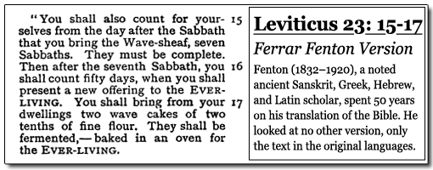
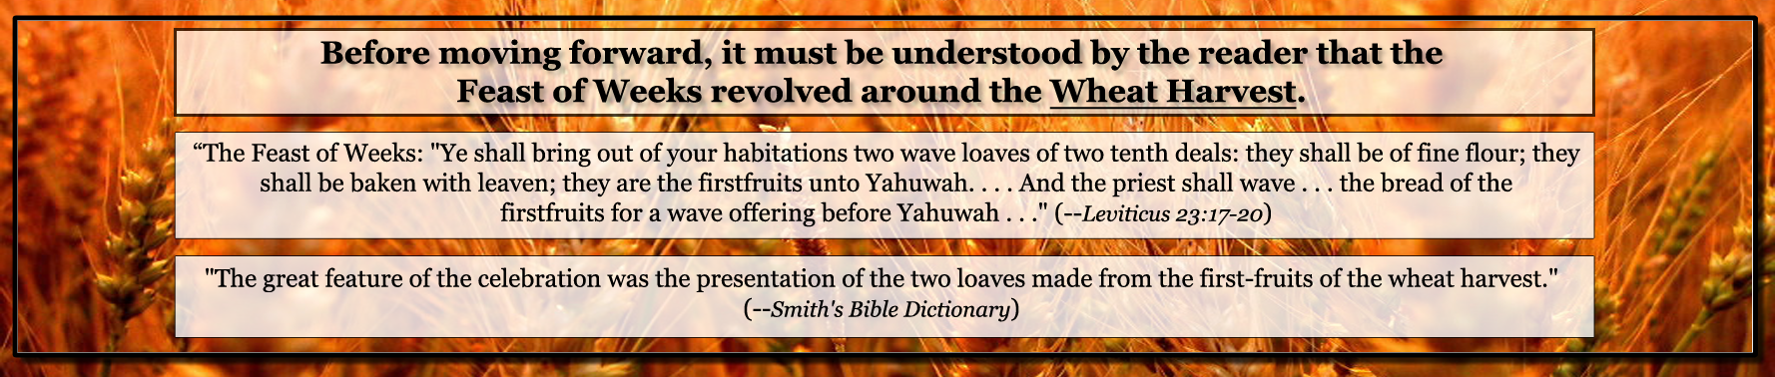
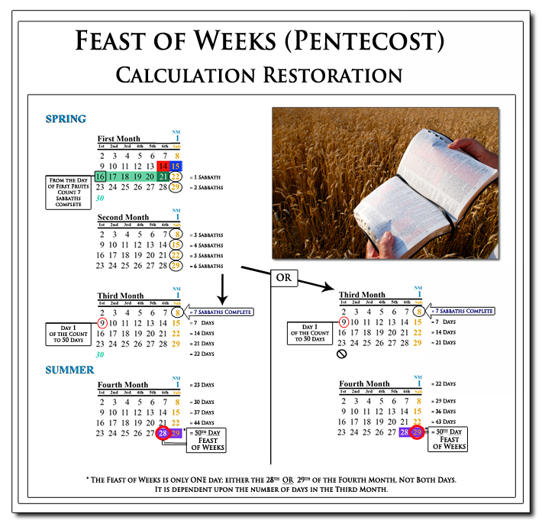
With this understanding we can clearly see that the omer count to Pentecost is not adversely affected in any way by the observance of a lunar calendar or reckoning for the weekly Sabbath. This is because YEHOVAH God, in His infinite wisdom, designed it that way!
Graphics courtesy WorldsLastChance.com
Hope of Israel Ministries -- Taking the Lead in the Search for Truth!

Hope of Israel Ministries  P.O. Box 853  Azusa, CA 91702, U.S.A.  www.hope-of-israel.org |  | Scan with your  Smartphone for  more information

